1. General questions –
   1. running the script depends on credentials to AHREFS. Right now you are using the login and password for [luan@techrius.com](mailto:luan@techrius.com) , but when I will run in the future I will need to use my login and password. Is there a way for me to insert that so the script uses that?
   2. The step “Then merge output-1.xls and output-2.xls to one file >> output-3.xls” – is that something that I do manually?
   3. Is there any limitations that I need to be aware of when I run the scripts?
      1. Is there a limit to the number of rows that I can have in file input.xls?
      2. How long will it take to generate output-1.xls on an input.xls file with 1000 rows? With 10,000 rows?
      3. Similarly – how long will it take to run the other scripts?
      4. Are there any limitations because of AHREFS that I need to be aware of, as I’m running the script? Like any of these that the scripts depends on?
      5. 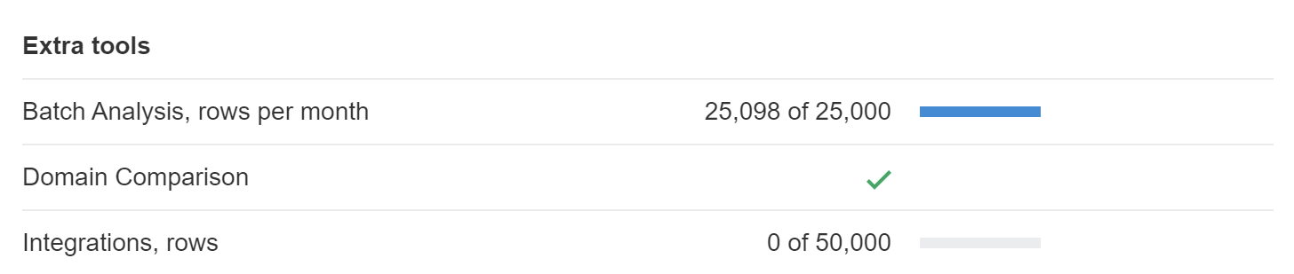
      6. 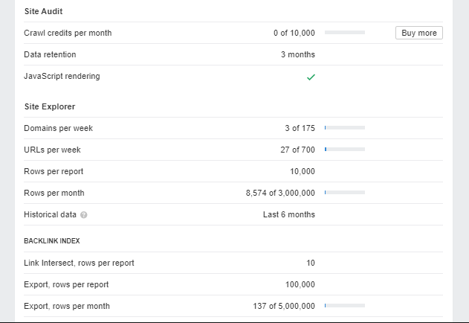
2. I realized that one reason for this being difficult is that there are root domains in input.xls, and these pages (the domains) have too many backlinks. **Before we even get started generating output-1.xls**, is there a way to go over **input.xls** and then **find and remove all URLs that are root domains**? for example, I would like to remove URLs like:
   1. [*http://ascendrehabinc.org/*](http://ascendrehabinc.org/)
   2. [*http://brynawel.org/*](http://brynawel.org/)
   3. [*http://dfsp.org/*](http://dfsp.org/)
   4. [*http://kool.corrections.ky.gov/*](http://kool.corrections.ky.gov/)
   5. [*www.hhs.gov/*](http://www.hhs.gov/)
   6. [*www.hhs.gov*](http://www.hhs.gov)
3. Right now, the file output-1.xls does not include some of the URLs that were needed to be put into AHREFS. For example: <http://abcdseattle.com/helpful-resources/>
   1. Is that only because the missing URLs do not have any backlinks to that URL (for example – the URL above gives me this: <https://ahrefs.com/site-explorer/backlinks/v7/external-similar-links/exact/live/all/all/dofollow/1/domain_rank_desc?target=abcdseattle.com%2Fhelpful-resources%2F> )
4. In the file output-1.xls there are some URLs where you have empty lines. You can see those under the column “Target” (column E in output1.mls) Usually these are root domains:
   1. [www.mass.gov/](http://www.mass.gov/)
   2. [www.samhsa.gov/](http://www.samhsa.gov/)